**3-2 Hands-On Project**

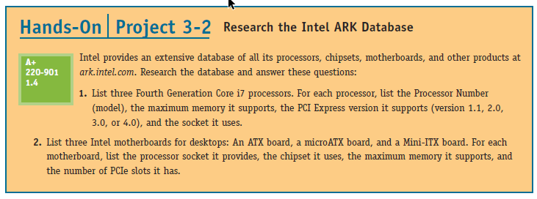

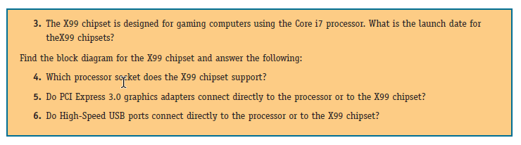**1.**

|  |  |  |  |  |
| --- | --- | --- | --- | --- |
| [Intel® Core™ i7-4900MQ Processor](https://ark.intel.com/products/75131/Intel-Core-i7-4900MQ-Processor-8M-Cache-up-to-3_80-GHz) | i7-4900MQ | 32 GB | 3.0 | FCPGA946 |
| Intel® Core™ i7-4700EQ Processor | i7-4700EQ | 32 GB | 3.0 | FCBGA1364 |
| [4th Generation Intel® Core™ i7 Processors](https://ark.intel.com/products/series/75023/4th-Generation-Intel-Core-i7-Processors) | i7-4578U | 16 GB | 2.0 | FCBGA1168 |

**2.**

|  |  |  |  |  |
| --- | --- | --- | --- | --- |
|  | **Processor socket** | **chipset** | **Max memory** | **PCIe slots** |
| ASRock X99 Extreme4 (**ATX**) | **LGA 2011-v3** | **X99** | **128** gigs (DDR4) | **5** |
| GIGABYTE G1 Gaming GA-X99M-GAMING 5 | **LGA 2011-v3** | **X99** | **32** gigs (DDR4) | **2** |
| ASRock X99E-ITX/ac (**Mini ITX**) | **LGA 2011-v3** | **X99** | **32** gigs (DDR4) | **1** |

3. August of 2014

4. 2011-v3

5. They connect to the X99 chipset

6. The high-speed USB ports connect to the X99 chipset